# Game Design Document Group 10

Table of Contents

Game Design Document Group 10 1

Game Overview 2

Introduction 2

Target Audience 2

Platform 2

Game Setting 2

Story 2

Characters 2

Game Mechanics 3

Gameplay 3

Physics 3

Artificial Intelligence 3

Game Elements 4

Level 4

Minigames 4

Art 4

Sound and Music 5

User interface, Game Controls 6

UI 6

Controls 6

MoSCoW 6

Must be done 6

Should be done 6

Could be done 7

Won’t be done 7

## Game Overview

### Introduction

Our game is a fast, unpredictable and highly competitive 4 player 3D racing game. Players will race from one checkpoint to another in a constantly changing arena, when the checkpoint is reached players will be placed into teams (free for all, 2 vs. 2 or 3 vs. 1), receive handicaps depending on their performance and play a minigame. The winner of the minigame get a point, first player to get 3 points wins.

### Target Audience

The intended audience for this game is primarily casual gamers who like playing racing games with friends since the game can only be played using LAN multiplayer. But we think other gamers will also find this game a lot of fun thanks to the minigames.

### Platform

This game will be made for the PC.

## Game Setting

### Story

At the start of the game the 4 players and their cars are dropped inside an arena somewhere on earth. They will battle against each other in minigames. Winning these minigames earns you points but there is a catch… The players must first race to a checkpoint, finish last and you might have a hard time winning the next game.

### Characters

There aren’t a lot of characters in this game. The game is a 4 player multiplayer so there are 4 different cars available for the players. Each player can choose 1 of the 4 available cars at the start of the game. These cars will have identical performance but different appearance. Besides the player characters there are also some enemies in the game, players will encounter these enemies during the minigames.

**Players:**

* Red car
* Blue car
* Green car
* Yellow car

**Enemies:**

* Zombies (follow the player when in range)
* Other enemies (unconfirmed)

## Game Mechanics

### Gameplay

Players have a 3rd person view of their character and are able to move it freely inside the arena. While driving towards the checkpoint objects will appear, disappear or move, forcing the players to alter their route. At the bottom of the view players can see a mini-map which they can use to find the location of enemies and other players. During the race players have no health bar and cannot die, when all players reach the checkpoint the race is over and a minigame will start. The minigames will be played in the same arena. Depending on the player’s performance he/she will have a better chance of winning the minigame. At the start of the minigame players will be placed into teams, the teams will be visible at the top of the screen. At the end of a minigame all team members of the winning team will receive a point and a new checkpoint race will start immediately. The game is very fast paced and will keep challenging players since arena always changes.

### Physics

* Player can collide with each other. This can damage players during some minigames.
* Players can’t go through or move large props such as houses and windmills.
* Player can move smaller objects, collisions will result in the player pushing the object.
* Car movement is controlled by adding forces therefore the cars need time to accelerate and decelerate just like real cars. This gives the game a very natural feeling.
* All characters are affected by gravity.
* Players can shoot bullets. These are not affected by gravity and won’t transfer forces to the objects they hit but they will damage players and enemies.

### Artificial Intelligence

**Enemies:**

Players will encounter several enemies during minigames, these enemies have some have some form of intelligence. When a player gets within a certain range of the enemy it will start chasing and attacking the player. When multiple players are within the enemy’s range it will attack the closest player. The enemy will ‘lose’ the player when he/she gets outside of the enemy’s range again.

**Arena:**

The arena is very special because it changes during the game. It knows where the players are and shift objects around creating new routes or blocking old ones. The arena is very open but filled with props such as buildings. When a new checkpoint has to be placed in the arena it will check where all the players are and use this information to place it so everybody needs to travel the same distance.

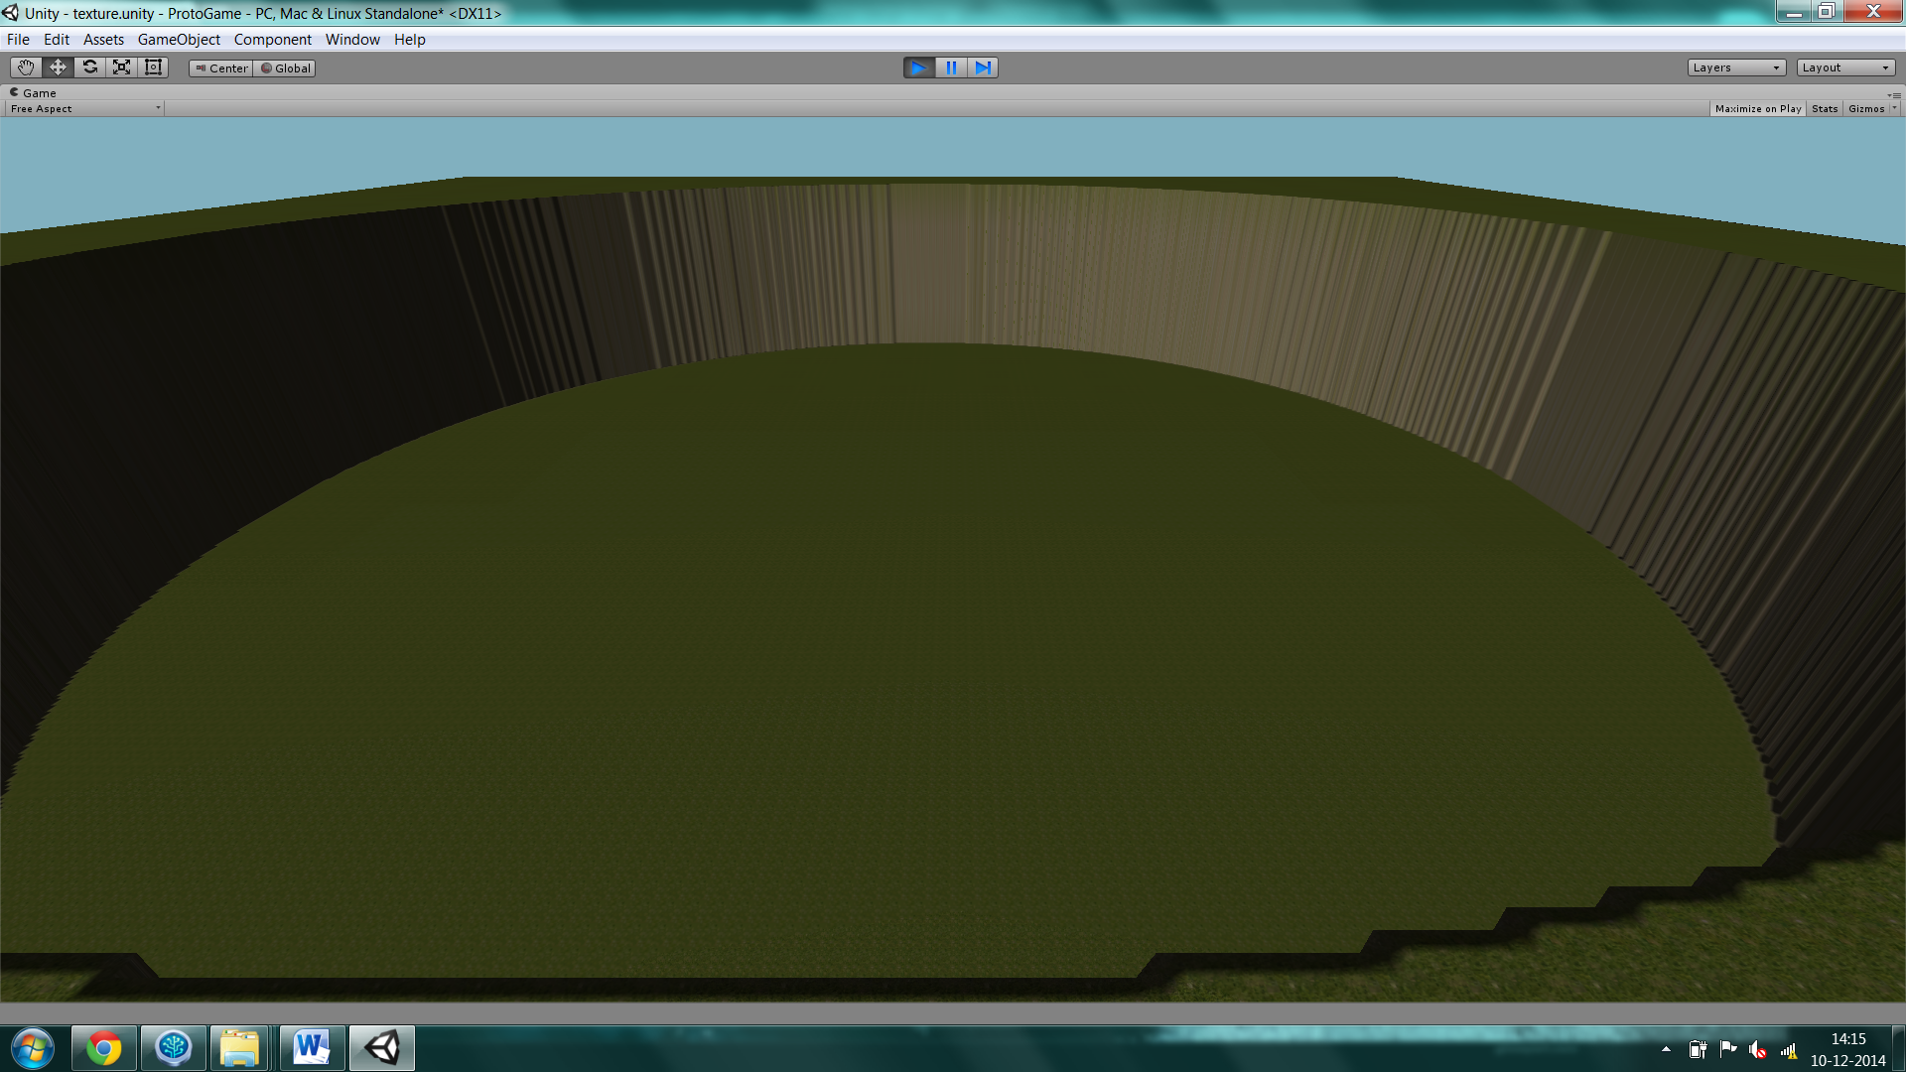

*Arena*

## Game Elements

### Level

This game has just one level, this level consist of an arena in which the players race, but don’t expect this game to be boring. For every game the arena is randomly generated so players won’t know the layout until the game starts. Even during gameplay things will change forcing you to rethink your strategy. Elements of the arena will randomly change so players must stay focused in order to win.

### Minigames

Minigames will start after a checkpoint race and currently there are 2 minigames in the game: Tron and invasion.

**Tron:**

During the tron minigame players will have a constant forward speed and create a trail behind them. Touching a trail (including your own) will kill the player. The objective is to stay alive and eliminate the other players. Last player alive wins the minigame and receives a point.

**Invasion:**

During the invasion minigame zombie cars will spawn and attack the players. These zombies will follow players around as long as they are in range. The objective of this minigame is to kill as many zombies as possible. The player/team with the most kills wins the minigame and receives a point.

### Art

The game will be a realistic racing game that takes place inside an arena somewhere in the desert. Most models and textures will fit into this description.

The models needed for this game are:

* 4 car models for the players
* Multiple enemy models
* Small prop models such as bushes and rocks
* Larger prop models such as trees and houses

The car models will be inspired by dune buggies and have a tube construction. All cars will have the same base structure but differences in colors and textures will make the cars look differently.

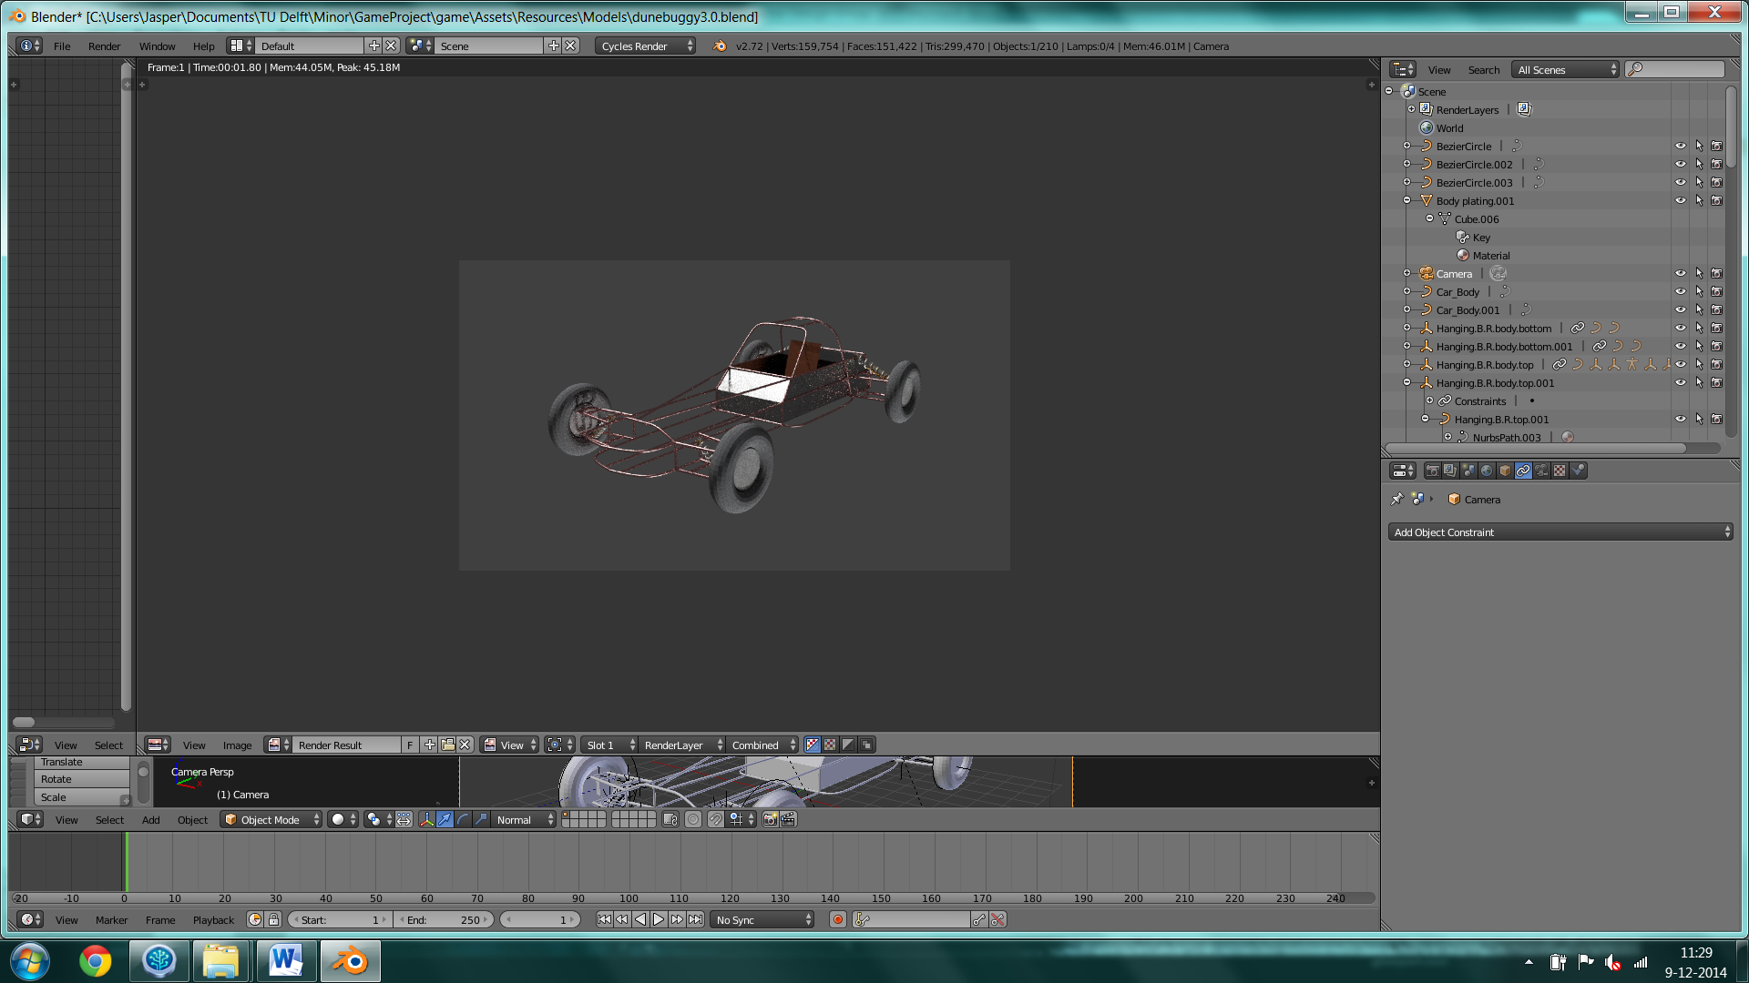

*Dune buggy model*

The enemies are used in minigames, these minigames can have different themes so the not all enemies will be in the same desert style. This will give the game a nice twist and catch players of guard.

The props are really important because they make the game feel alive and realistic. Without these props the arena would be very empty and not very interesting to race in. The location of the props will also change each time you play the game so players will get the feeling they are racing in a new arena and playing the game will remain fun interesting even after hours of playing.

### Sound and Music

The game takes place in the desert so the music will fit this theme. Since this is a fast racing game fast paced background music should give the game a nice feel. In the game there will be sound effects for the following event:

* Engine noise
* Car collisions
* Destroying objects/enemies
* Shooting
* Getting hit by shots

The sound effects in this game are really important without them the game wouldn’t very interesting to play. One of the most important sound effects is the engine noise, the engine noise gives the player more feedback on what the car is doing.

Other sound effects give the game more ‘juiciness’ and make it more interesting to play.

## User interface, Game Controls

### UI

When the player starts the game they will see the start menu, in this menu players will have several options:

* You can host a new game using the create game button
* You can join a game using the join button and entering the host’s IP address in a bar
* You can view the controls using the controls button

When a player decides to play a game they can select the car they want to drive by clicking one of the 4 car images. There can only be one car of each color in the game.

### Controls

Players can control the car that they are driving in and perform other actions such as shooting.

* Accelerate – up arrow
* Reverse – down arrow
* Steer left – left arrow
* Steer right – right arrow
* Hand brake – left shift
* Shoot – spacebar
* More options will be added

## MoSCoW

### Must be done

There are several major components this game must have in order to be a functional game. Our game concept involves a level that is procedurally generated and changes during gameplay so creating this is something that must be done in order for the game to work. Since this is a checkpoint racing game spawning checkpoints is another crucial component otherwise players would have nothing to do. The last component that must be in this game is minigames, players need to battle each other in order win so not implementing minigames isn’t an option.

### Should be done

We want the car controls to feel very natural so implementing a good player controller should be done but the game would still function with a bit less realistic controls. Besides a good player controller we want to implement some other nice features such as a mini-map and a rearview camera, obviously we want to implement those features but they don’t have the highest priority. The last thing that should be done is implementing features that give the game more ‘juiciness’ such as sound effects, particle effect and camera shakes.

### Could be done

Having more minigames would obviously make the game more fun to play so if everything goes well we will create more minigames.

### Won’t be done

Initially this game was supposed to be an online multiplayer game however we decided that creating a good online multiplayer game is too difficult for us to accomplish in the time we have. Therefore we will make this game a LAN multiplayer game instead of online multiplayer.